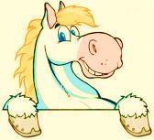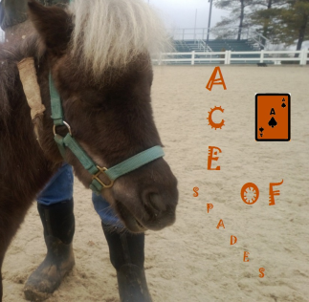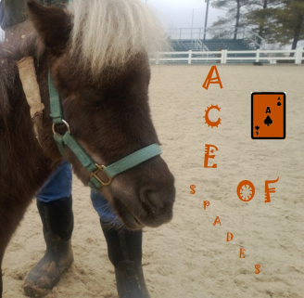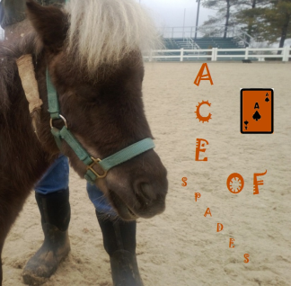

**EKU Library Guide**

**EKU Library Guide**

**EKU Library Guide**

**EKU Library Guide**

## **Horse Grooming**

* The mane and tale can make or break a show.
* The mane is braided or knotted to look neat and tidy
* The mane and tale help keep the horse warm and keep the flies away.

## **Horse Grooming**

* The mane and tale can make or break a show.
* The mane is braided or knotted to look neat and tidy
* The mane and tale help keep the horse warm and keep the flies away.

## **Horse Grooming**

* The mane and tale can make or break a show.
* The mane is braided or knotted to look neat and tidy
* The mane and tale help keep the horse warm and keep the flies away.

## **Horse Grooming**

* The mane and tale can make or break a show.
* The mane is braided or knotted to look neat and tidy
* The mane and tale help keep the horse warm and keep the flies away.

**EKU Library Guide**

## **Horse Grooming**

* The mane and tale can make or break a show.
* The mane is braided or knotted to look neat and tidy
* The mane and tale help keep the horse warm and keep the flies away.

┘ ┴ ┴ ┴ ┴ └

┘ ┴ ┴ ┴ ┴ └

**My Story!**

**My Story!**

**My Story!**

**My Story!**

**My Story!**

Hi my name is ACE. I am an American Miniature horse

I have been at the Kentucky horse park for 2 years now learning all kinds of new tricks! I would love if you would stop by and see me : )

Hi my name is ACE. I am an American Miniature horse

I have been at the Kentucky horse park for 2 years now learning all kinds of new tricks! I would love if you would stop by and see me : )

Hi my name is ACE. I am an American Miniature horse

I have been at the Kentucky horse park for 2 years now learning all kinds of new tricks! I would love if you would stop by and see me : )

Hi my name is ACE. I am an American Miniature horse

I have been at the Kentucky horse park for 2 years now learning all kinds of new tricks! I would love if you would stop by and see me : )

Hi my name is ACE. I am an American Miniature horse

I have been at the Kentucky horse park for 2 years now learning all kinds of new tricks! I would love if you would stop by and see me : )